European Parliament  2019-2024 | 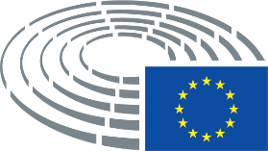

<Commission>{D-IL}Delegation for relations with Israel</Commission>

<DocRef>D-IL_OJ(2020)1214_1</DocRef>
<TitreType>DRAFT AGENDA</TitreType>
Meeting
<Titre>Monday 14 December 2020, 11.00-12.30</Titre>
Brussels
Remotely with WEBEX

1. Adoption of agenda (PE 646.233)

2. Chair's announcements

3. Exchange of views on the significance, for Israel and the region, of the agreement announced on the 10th December 2020, between the State of Israel and the Kingdom of Morocco, in the presence of HE Ambassador Ahmed Rahhou, Head of the Mission of Morocco to the EU and NATO

4. Exchange of views on the EU - Israel cooperation on security and regional challenges:

- Presentation by Ms Sima Shine, Head of Iran program at the Institute for National Security Studies (INSS) from Israel

- Participation of Mr. Neal Mac Call, Head of Division Middle East II, European External Action Service

5. Any other business

6. Date and place of the next meeting

